Programming Exercise
Questions
- What change was needed for the app to now respond to class to http://localhost:5000/tasks instead of http://localhost:5000/students?

The main change required was updating all Flask route decorators from /students to /tasks. Including the POST, PUT, GET, and DELETE endpoints. Changing the route paths allows the application to listen for requests sent to /tasks instead of /students. I also changed the function names and internal variable names for clarity (students to tasks and age to status). The most important change was modifying the @app.route() paths so Flask correctly maps incoming HTTP requests to the new task-based endpoints.

- What code did you use to list the tasks in the GET operation?

In the GET operation I used a loop that iterates through the dictionary storing the tasks and builds a formatted string of all entries. Each key-value pair (task and status) was concatenated into a single string with a newline separator. The final string is then returned with a 200 status code. The new code is:

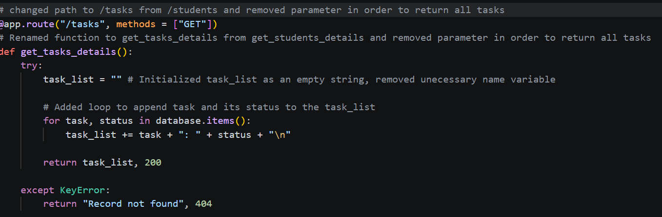
This converts the dictionary into a readable list format for the client.

- What status code does the following call return?
http://localhost:5000/tasks/get
This request will return a 404 Not Found status code. There is not a Flask route defined for /tasks/get. The valid GET endpoint in the application is /tasks, not /tasks/get. If Flask cannot match the requested URL to any existing route, it outputs a 404 error indicating that the resource does not exist on the server.

